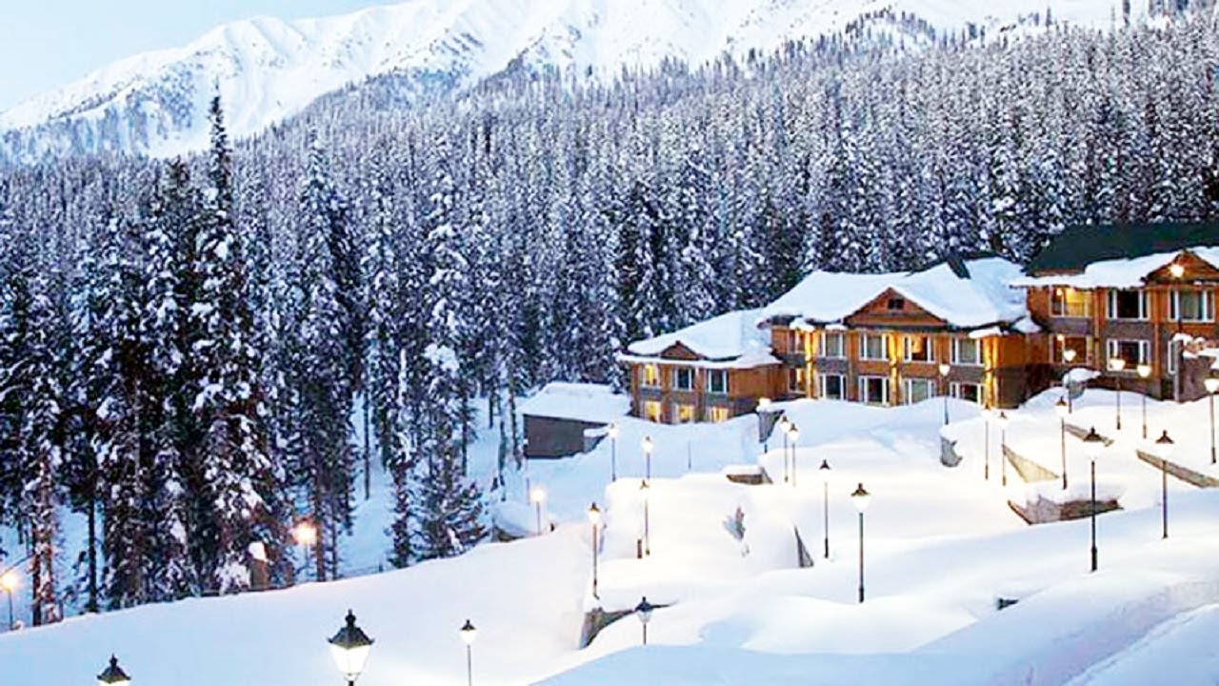

**All**

**Inclusive**

**Package**

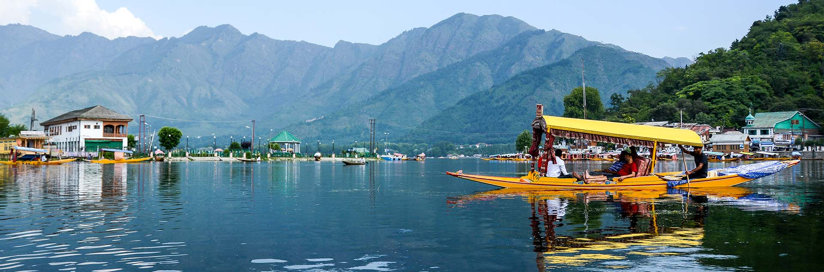

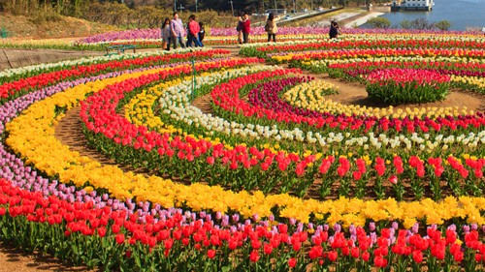

**Escorted**

**Group**

**Departure**

**KASHMIR**

**5 Days 4 Hotel Nights**

**11111111111111111**

**Tulip Special**

**TOUR HIGHLIGHTS & SIGHTSEEING**

**Srinagar** | **Gulmarg Pahalgam**

**THE PARADISE ON EARTH**

**Srinagar** **(3N)** | **Houseboat @ Dal Lake** **(1N)**

**Srinagar:** Dal Lake, Shikara Ride to Floating Market (1 Hour) Indira Gandhi Memorial Tulip Garden **(Special Tulip Festival)**, Shankaracharya Temple, Shalimar Garden, Jamia Masjid, Chashma Shahi Garden, Pari Mahal & Nigeen Lake View

**Gulmarg:** Full Day Trip |Gondola Ride to Phase 1 (Included) *Snow Activities at Phase 1 is on direct payment basis*

**Pahalgam:** Mamal Temple, Avantipura Ruins, Liddar River,

Visit to **Aru, Betaab Valley & Chandanwari** (Taxi – Local Union)

**All Inclusive Package Includes**

**3 Star** Category Hotel Accommodation | Return Airport Transfers

All Meals – **Breakfast, Lunch & Dinner** | All Day – **Private Vehicle**

**Entry Fees & Transfers** to attractions mentioned in the Highlights

Driver Allowance | Parking Fees | National / State Entry Permits

**GST** & other local Taxes | Tolls | Pre Departure Meeting | Travel Kit

Service of an **Experienced Tour Manager** & All time **Local Guide**



**SPECIAL INCLUSION**

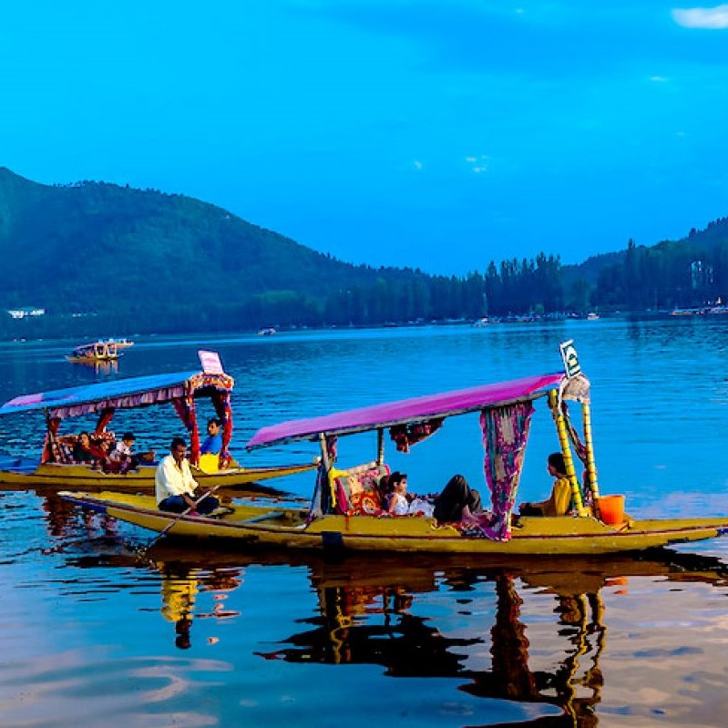

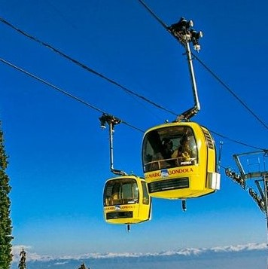

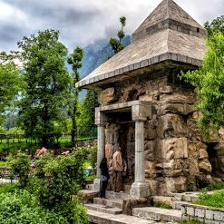

**This Tour Package does not include Airfare**



**Arrival To: Srinagar** | **Departure from: Srinagar**

The **Approximate Round Trip Airfare** would be

**Ex: Bangalore** – **Rs. 13,000** | **Ex: Mangalore** – **Rs. 18,000**

However, we can book the Air Tickets for you as per the **Actual Airfare** prevailing at the time of **Tour Reservation**

**Dal Lake Shikara Ride Tulip Garden Gulmarg Gondola Pahalgam Temple**

**Note: Offer with effect from 10th February 2021**

* **Tour cost is on Twin / Triple Share basis**. Surcharges are applicable for Single Sharing.

Tour Cost per person: **Rs. 26,000** /- (Reserve before 30 days)

Tour Cost per person: **Rs. 28,000** /- (Last Minute Reservation)

* **Child below 4 Years travels for FREE (Land package only). Actual Airfare / Train fare to be paid.**
* **Child** (below 11 Years) **is entitled for special discounts as mentioned below (with Actual Airfare)**

Discount on the above Price: **Rs. 10,000** /- (Child without Extra Bed)

Discount on the above Price: **Rs. 5,000** /- (Child with Extra Bed)

* **All Inclusive – Special Offer is for the “LAND PACKAGE” only. This Package Includes** **5%** **GST.**
* **Please be aware of the “Latest State Wise – Entry Regulations” w.r.t. COVID 19 Travel Restrictions**
* **We would like to inform you that we are using Sanitized Coach, Hotels & Restaurants and we request you to kindly follow all the Regulations ruled out by the Government & Local Tourism Authority.**

**SPECIAL OFFER PRICE per person Rs. 22,900/-**

**Actual Tour Package Cost** (Before Discount)**: Rs. 28,000/-**

**Ex: Mangalore / Bangalore**

**Departure Date: 9th April 2021**

This special offer price is applicable only when you

Reserve this tour **45 days** prior to the departure date